
Power Extension Cable

PDS-CAB-PWCEXT-14
Feature
Wire End Rating | NEMA TYPE 3, 4
Wire End Hazardous Area Rating | Class I, Divisions 1 & 2, Groups B, C, D  Class I, Zones 1 & 2, Groups IIB + H², IIA  Class II, Divisions 1 & 2, Groups F, G  Class III
Wire End Connection Rating | 15 Amp 125VAC
Length | 100 ft / 30.48 m  300ft / 91.44 m
Cable Type | 14 AWG-3C Portable Cord SOOW 600V  -40C to +90C, CPE Jkt  UL, CSA, MSHA
Product Variants
PDS-CAB-PWCEXT-14-100 – Power extension cable, 100-foot
PDS-CAB-PWCEXT-14-300 – Power extension cable, 300-foot
Related Products
XPL-R5 – Explosion-Proof Light
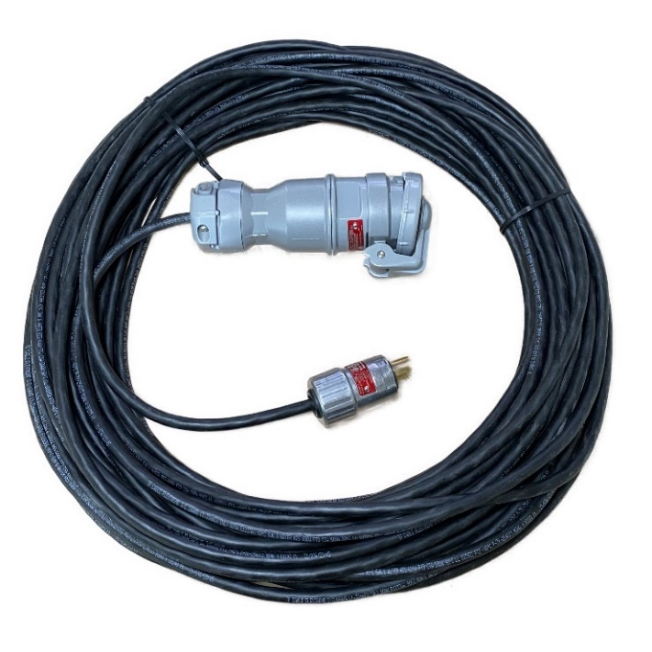
The cable certified for portable use in hazardous locations where flammable gases, liquids, vapors, combustible dusts, or fibers are present; this durable cable provides extended power to your needs reliably in wet, corrosive, and hazardous areas, both indoors and outdoors.

